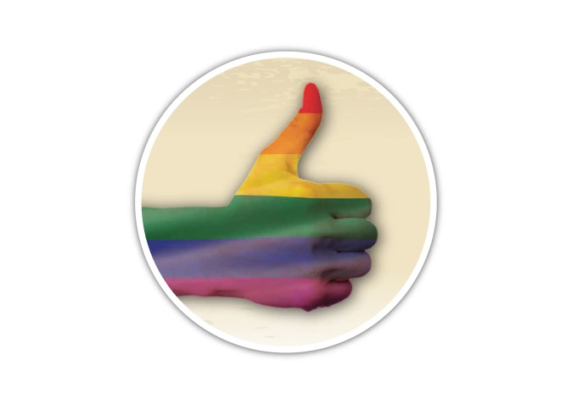
LGBT Domestic Abuse Disclosure Scheme in Buckinghamshire
A new domestic abuse disclosure scheme is being trialled for the Lesbian, Gay, Bisexual and Transgender (LGBT) community of Wycombe, Chiltern and South Bucks districts.

LGBT clients using the existing Terrence Higgins Trust service to access the HIV and sexual health drop in for information and advice will at the same time be able to disclose domestic abuse to the HIV and Sexual Health Practitioners in order to gain the support they need.

In the event of a disclosure of domestic abuse, staff will engage with the victim and assist them in booking an appointment with Wycombe Women’s Aid (for female victims) or SMART IDVA Service (for male victims) who will then meet the client at the Terrence Higgins drop in centre or an alternative safe location at a time convenient and safe for the client. In addition, a Police LAGLO (Lesbian and Gay Liaison Officer) can be available at the drop in via an appointment basis regarding domestic abuse or other issues.

This service is available every Monday from 9:30-12:30 and clients can either pop in to the drop in centre: Terrence Higgins Trust, Oasis House, George Street, High Wycombe, Bucks, HP11 2RZ, or call Terrence Higgins staff on 01494 520436.




